**Power BI Sales Analysis Documentation**

**Sales Trends Overview:**

Sales data shows that outlets established in 1985 demonstrate strong performance, highlighting the value of longevity and customer loyalty.

Recent outlets, like those from 2010, exhibit promising initial sales, indicating successful market entries.

'Supermarket Type1' outlets lead in sales, underscoring a preference for this shopping format.

**Average Sales Analysis:**

The dashboard provides an average sales metric, essential for comparing outlet performance and spotting outliers.

**Strategic Recommendations:**

Prioritize investment in proven outlet types and explore successful strategies from newer outlets.

Enhance older, high-performing outlets to sustain their market leadership..

The sales data is segmented by the 'Outlet_Type' dimension and further broken down by 'Outlet_Establishment_Year' to illustrate trends over time.

Conclusion

The dashboard underscores the dynamic nature of sales across different outlet types and periods. By leveraging these insights, businesses can tailor their strategies for inventory management, marketing campaigns, and expansion plans to drive sales growth.Sales Performance by Item Type

Top-Selling Categories: **'Fruits and Vegetables', 'Snack Foods'.**

Underperforming Categories: '**Seafood', 'Breakfast', 'Others'.**

Explanation: Categories with higher sales volumes, such as 'Fruits and Vegetables' and 'Snack Foods', indicate strong consumer demand and regular turnover. In contrast, 'Seafood' and other underperforming categories may require targeted marketing to increase sales.

Average MRP by Outlet Size

High MRP: **Larger outlet sizes.**

Lower MRP: **Smaller outlet sizes.**

Explanation: The higher average MRP in larger outlets suggests a strategy of stocking more premium items or having a wider variety of products. Smaller outlets might focus on more competitively priced or essential items.

Outlet Performance Over Time

Established Outlets (e.g., 1985): **Highest cumulative sales.**

Recent Outlets (e.g., 2010): **Lower but promising initial sales.**

Explanation: Outlets with a longer presence in the market tend to have accumulated higher total sales, likely due to established customer loyalty and brand recognition. Newer outlets showing promising sales indicate successful entry into the market and potential for growth.

Median Sales by Item Type

Consistent Performers: Categories with a high median sales value.

Explanation: The median sales value gives a sense of typical sales performance, unaffected by extreme values. Categories with higher median sales are likely to have a steady demand across outlets.

**Sum of Total Sales**

Cumulative Sales: **$18,591,125.41**.

Explanation: This total sales figure gives a macro-level view of the performance across all items and outlets, serving as a benchmark for the health of overall sales activities.

Average Sales by Category by Item Type

Higher Average Sales: Categories such as 'Starchy Foods' and 'Seafood'.

Lower Average Sales: Categories such as 'Others' and 'Baking Goods'.

Explanation: Higher average sales in certain categories indicate their popularity or a higher number of high-value items within those categories, which can inform inventory and pricing strategies.

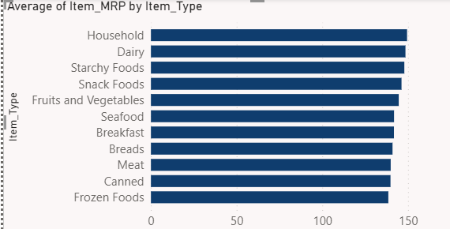

The average Maximum Retail Price (MRP) by Item_Type from the Train.csv dataset is as follows:

Based on the provided average Maximum Retail Price (MRP) figures for each item category, the analysis indicates that the Household category is the highest performer with an average MRP of $149.42.

Household items have the highest average MRP at $149.42, suggesting a premium positioning within the product mix. Dairy and Starchy Foods follow, reflecting their higher value perception. In contrast, Baking Goods, Health and Hygi ene, and Soft Drinks are at lower MRPs, indicating a focus on cost-competitiveness and volume sales.

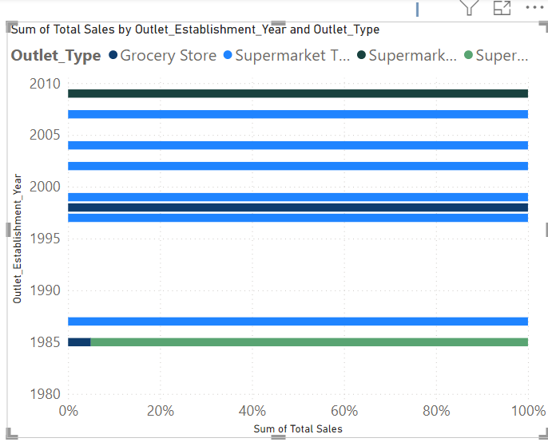

Outlets established in 1985 lead with the highest sales at approximately **$3.63** million, indicating long-term market success. Recent outlets from 2009 are still gaining traction with **$1.85** million in sales. Outlets from 1998 show notably lower performance, with sales around $190,000, signaling potential operational or market challenges.

Outlets established in 1985 have the highest sales with 3.19M, making up 17.17% of total sales.

Outlets from 1987, 1999, 1997, 2004, 2002, and 2009 follow closely, each contributing over 2.00M to the sales.

The outlet established in 2007 is the lowest among the compared years, contributing less to the total sales.

Supermarket Type1 leads with the highest sales performance, summing to **$13,897.10**.

Supermarket Type3 follows, with a total sum of **$3,694.04** in average sales.

Grocery Store ranks lowest, with a sum of **$679.68,** indicating the least sales efficiency.

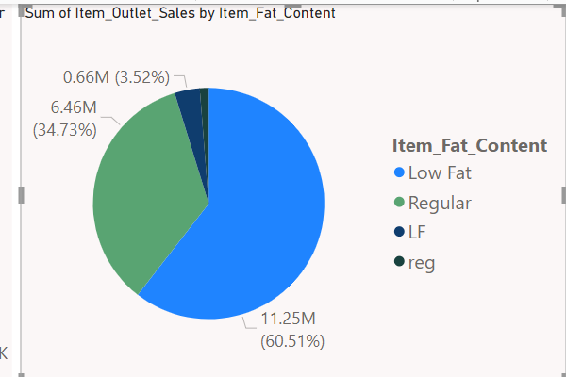

"Low Fat" items lead with sales of **$11,015,030**, while "reg" items record the lowest **at $229,576.50,** underscoring a preference for healthier options.

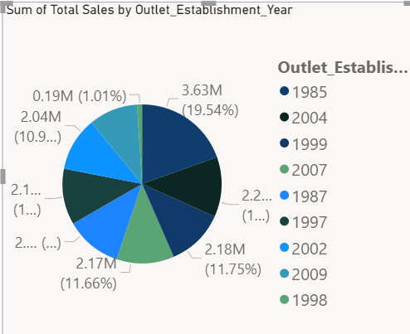

**The top three performing outlets by establishment year, based on total sales**, are:

1985 with sales of **$3,633,620,** indicating the highest sales among all outlets.

2004 with sales of **$2,268,123,** showcasing strong performance.

1999 with sales of **$2,183,970,** also indicating robust sales figures.

**The lowest three performers are**:

1998 with sales of **$188,340,** significantly lower than other outlets.

2009 with sales of **$1,851,823**, the lowest among the more recently established outlets.

1987 and 1997 are closely matched in performance, but both are among the lower sales figures compared to the top performers.

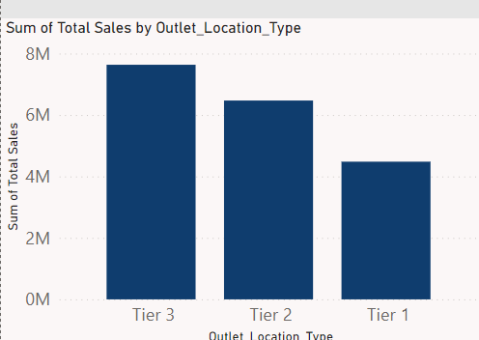

"**Sum of Total Sales by Outlet Location Type**" from the dataset is as follows:

Tier 3: Total Sales of approximately **$7,636,753**

Tier 2: Total Sales of approximately **$6,472,314**

Tier 1: Total Sales of approximately **$4,482,059**

These figures indicate that outlets located in Tier 3 areas have the highest total sales, followed by those in Tier 2, with Tier 1 areas generating the least total sales

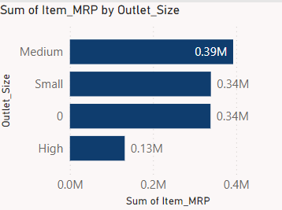

Medium: Total Item MRP of approximately **$369,012.30**

Small: Total Item MRP of approximately **$319,779.62**

High: Total Item MRP of approximately **$123,415.11**

Medium-sized outlets have the highest cumulative MRP for items, followed by small outlets, with high-sized outlets having the lowest sum of MRP. This could suggest a broader or more expensive product mix in medium-sized outlets.

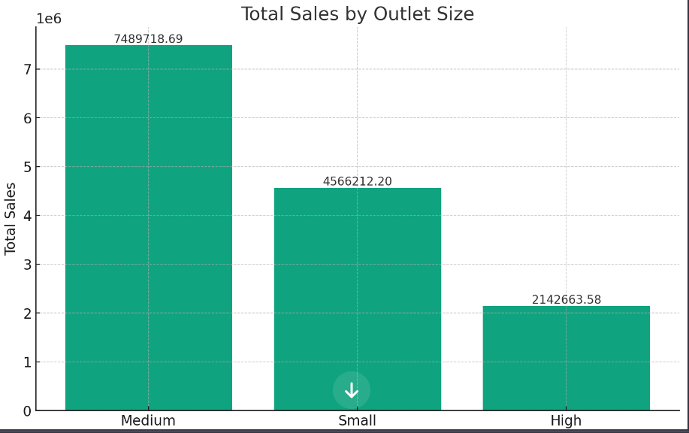

Medium-sized outlets have the highest total sales, amounting to approximately **$7,489,719**.

Small-sized outlets follow with total sales of approximately **$4,566,212**.

High-sized outlets have the lowest total sales, with approximately **$2,142,664.**